Supply Chain and Operations Strategy
(DD/MM/YYYY)

Contents
Introduction 2
1. Evaluation of Concepts and Principles of Operations and Supply Chain Management 2
2. Key Drivers of Effective Supply Chain Management 4
3. Assessment of Effective Operations and Supply Chain Management Competitiveness 6
4. Critical Evaluation of Key Decisions to Improve Supply Chain and Operations 7
5. Application of Strategic Approaches to Supply Chain and Operations Management 8
6. Performance Measurement within Supply Chain and Operations Management 10
7. Financial, Non-Financial, Single and MultifactorMultifactor Performance Measures 11
Eight key performance indicators at Intel's highest operations and supply chain management level. 12
9. Intra- and Inter-Organizational Benchmarking 13
Intra-organizational Benchmarking 13
Inter-organizational Benchmarking 14
References 15

Introduction

1. Evaluation of Concepts and Principles of Operations and Supply Chain Management
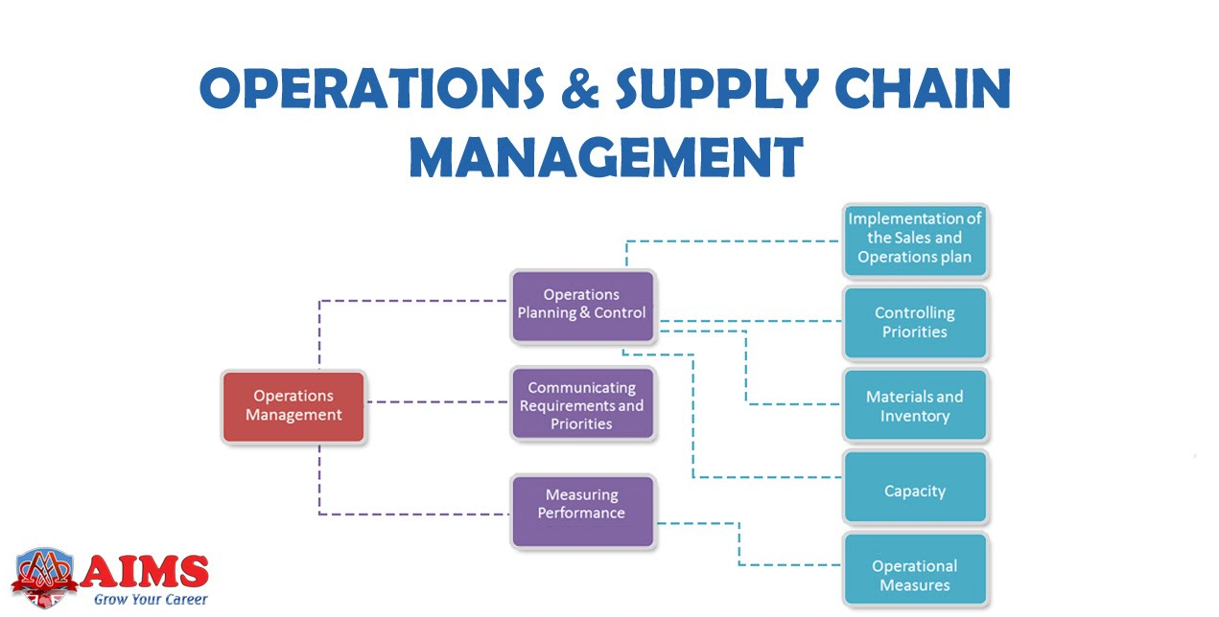
(Pasi et al., 2020).
Operational and supply chain management (SCM) is the department of the manufacturing industry in which production must be efficient and cost-effective. The task for Intel's Atom chip has been that instead of solely cutting the supply chain costs, some innovative tactics were needed to maintain the quality of the products. This discussion dives into the methods, philosophies, and concepts essential to Intel's strategy for improving its supply chain.
Lean Principles: Cost-cutting has always been at the forefront of Intel's strategy, which best illustrates lean theory in SCM. Lean thinking prevents unnecessary activities and increases the scope of value-adding ones (Palange and Dhatrak, 2021). The company Intel succeeded in eliminating the wasteful points in the supply line that led to wasted resources and needless costs by rationally positioning the processes. That way, it managed to maintain the quality while reducing costs. By taking as an example the reduced order cycle time from nine weeks to just two weeks, the inventory holding costs were drastically minimized, and responsiveness to customer demand and agility of the organization to external market stimuli have been enhanced. Implementing better assembly processes also helped reduce the cost incurred on operations, thereby measuring operational efficiency.
Agile Manufacturing: Agility manufacturing practices were essential in Intel's supply chain transformation. The agile manufacturing system focuses more on adaptability, speedy response, and efficient adjustment to market conditions (Varl et al., 2020). Implementing a make-to-order strategy and uniting it with the wise sales and operations planning (S&OP) procedure has proved an excellent method of maintaining agility. This was made possible by initiatives such as stocking small items locally and not holding inventory in bulk, leading to lean inventories and flexibility throughout the supply chain. Reducing unneeded surplus and excess stock to the stock level that constitutes current demand is a way of mitigating the chance of overproduction and the proper utilization of resources and, therefore, boosting profitability.
Vendor-Managed Inventory (VMI): Using a VMI (Vendor-Managed Inventory) approach strengthened our supply chain. VMI is slated to relinquish inventory control for the partnering suppliers and save time and effort for depleted internal resources. With supply partners working side by side and the background of the VMI approach, Intel ensured better visibility and cooperation in the entire supply chain. This was a highly efficient mode of operation as it negated the need for transporting surplus stocks, streamlined the inventory management procedures, and reduced the holding cost. Additionally, by teaming up with suppliers' strengths in other areas like inventory management, Intel was able to lessen lead times, optimize supply levels, and boost overall supply chain performance.
Continuous Improvement: The supply chain culture should optimize for long-range high performance and minimize wasting resources to ensure sustainable operational excellence and ongoing efficiency improvements (Carvalho et al., 2021). The primary recipe for cutting down the supply chain costs by Intel was not a one-time undertaking but a hectic result of a whole system-made effort to look inward and tackle every single gap. By cultivating a culture of perpetual improvement, Intel initiated employees from all levels to resolve unproductively, thus making them capable of innovation. Intel accomplished substantial savings over time by frequently tracking, examining, and altering its supply chain and process. However, it kept its product quality and customer satisfaction the same. Continuous improvement moves also have critical roles in reengineering, performance benchmarking, and employee training that maintain an effective operational performance and long-term competitiveness.
As a result of its accomplishments, Intel's success in supply chain optimization can be explained through the correct usage of lean principles, agile manufacturing, and VMI, as well as its steadfast focus on process innovation. Applying these concepts and principles to the tasks Intel was executing could power down the supply chain's cost-effectiveness and boost flexibility, response, and overall performance. Thus, Intel maintains a leading position in the semiconductor arena, which reflects the company's operational success and agility in a rapidly transforming world.

2. Key Drivers of Effective Supply Chain Management
Proper supply chain management (SCM) helps companies establish the necessary tools and procedures for smooth and streamlined processes, minimum costs, and customer satisfaction. Drawing insights from Intel's experience in optimizing its supply chain for the Atom chip, we can identify several key drivers that contribute to successful SCM: Drawing insights from Intel's experience in optimizing its supply chain for the Atom chip, we can identify several key drivers that contribute to successful SCM:
Visibility and Collaboration: Developing transparency in operational processes and having partnerships with suppliers and network partners are vital dynamics of SCM. Intel's adoption of Vendor-Managed Inventory (VMI) and participation in formal Sales and Operations Planning (S&OP) processes represents its willingness to enhance communication and collaboration, which would reduce supply chain risks. Through the joint efforts and shared objectives, the partnerships stated by Intel contributed to the seam of communication and coordination among the different chain links. Thanks to revolutionizing real-time visibility, it facilitated a truly proactive management style, optimized resource use, and enhanced supply chain performance.
Risk Management: Risk management proactively is vital for disruptive voiding and systemic continuity (Kure et al., 2022). The risk management policies of Intel Corporation have been made quite evident by the company's undertaking initiatives to minimize order cycle time inventories in various locations around the world. Intel not only shortened the order card time from the cycle time of nine weeks to only two weeks but also would able to decrease the exposure to risks associated with prolonged time and uncertainties of the market. Moreover, making the manufacturing operations of the two plants run simultaneously, especially the pilot operation in Malaysia, made the business network resilient; in so doing, the supply chain's susceptibility to disruption was reduced.
Flexibility and Responsiveness: Adaptability and flexibility are the two core components of the SCM implementation, and this is especially imperative in changeable market conditions (Jafari et al., 2023). Intel's choice of make-to-order production process and its application of the lean method have a clear message to its management: flexibility and responsiveness. Instead of throwing in chips that may or may not be wanted, Intel focused on producing chips on the order that went into the end product. Consequently, the resources used and profitability went higher, too. In addition, lean principles help Intel reduce unnecessary SKUs, processes, and steps to improve its responsiveness to the changing market demand and remain competitive.
Performance Measurement and Continuous Improvement: Creating an effective performance measurement system and maintaining a culture of continuous improvement could be critical differentiators for companies looking to drive efficiency and innovation in the supply chain (Le et al., 2022). Like Intel, when eliminating order cycle time and improving the process are concerns, the firm is interested in maximum efficiency and continual optimization of the SCM systems. Intel, through the creation of realistic goal-setting rules and the evaluation compared to the benchmarks, can currently point out its shortcomings and implement corrective measures to improve its efficiency and effectiveness. Apart from that, inspiring a spirit of continuous improvement would quicken the rate at which employees take up the opportunities for solution and innovation, consequently keeping Intel ahead of the pack in the lavish UMM practices. Good management and service levels are crucial to Intel's prominent position in meeting high standards while being cost-effective and valuable for its customers. Let the view of visibility, collaboration, risk management, flexibility, responsiveness, performance measurement, and improvement that Intel takes entirely be the proactive methods to SCM that the other companies aiming for operational effectiveness and competitiveness with global market leadership can follow. Intel has become the chairman of innovations and efficiency in the semiconductor industry's technological revolution through its relentless pursuit of state-of-the-art SCM excellence.

3. Assessment of Effective Operations and Supply Chain Management Competitiveness
As for the competitive environment, inadequate OW, operations, and supply chain management function, here's an assessment of how these functions contribute to competitiveness
1. Cost Efficiency: Linking production and supply chain processes with standard procedures can save costs in producing and storing less stuff, good use of recovering materials, and minimizing wastage (Gautam et al., 2021). Organizations will likely benefit from effective operations and supply chain management by providing competitive pricing and thus attracting price-sensitive consumers, which can bring more profits and leverage.
2. Customer Satisfaction: Effective SCM contributes wholly to on-time delivery of products, uniform quality, and alignment with customers 'demands. Through customer satisfaction or surpassing the demands, companies can establish favourability among their customers and differentiate themselves from their competitors. Happy clients bring more business and enthusiasm together, making it probable to win further contests.
3. Innovation and Flexibility: Smart management of a supply chain can ensure companies elevate their creativity and readiness to innovate to meet market demands and cope with technological progress. By working hand in hand with integrated teams of suppliers and partners, the companies enjoy direct access to emerging technologies and ideas, enabling them to invent new products and solutions rapidly compared to rival companies. Production process flexibilities help organizations adapt a new product or production quickly to changing market conditions; thus, it gives an organization an edge in the competitive market.
4. Risk Mitigation: Simply put, well-designed operations and SCM are a kind of guarantee for the business in the case of supply chain disruption (natural disasters, geopolitical conflicts, supplier failures, etc.) Through risk-sharing suppliers, companies can utilize sound risk management strategies and be built into the supply chain; a business can minimize disruptions and keep the running operations regular, thereby firming up the company's competitive edge.
5. Speed to Market: Powering the operations and managing the supply chain gives companies the advantage over their competitors to bring new products to the market in the shortest time possible (Ivanov et al., 2021). Such a quick response may enable the companies to take closely on market opportunities, giving them a first-mover advantage and allowing them to dominate the market before competitors appear.

4. Critical Evaluation of Key Decisions to Improve Supply Chain and Operations
Firms often plan their supply chain and production processes with a critical aim: to find new ways to achieve efficiency, cut costs, and meet or exceed the customers' needs. Here's a critical evaluation of crucial decisions in this regard
1. Outsourcing: Despite outsourcing potentially creating savings in costs and access to specific skills, it still has some risks, i.e., losing control over quality and a dependence on external suppliers. Businesses must be critical of the tradeoff and establish strong supply chain relationships to reduce risk and align with strategic objectives.
2. Technology Adoption: The application of technology, for example, through ERP systems, performing advanced analytics and automation, can enhance visibility, effectiveness, and production of a decision in supply and operations. Nevertheless, technology adoption implies significant financial investments at the outset, organizational adjustments, and the regular continuation of maintenance activities. Organizations have to probingly weigh the pros and cons of technology uptake and ensure its commitment to the company's primary aims.
3. Inventory Management: Managing the inventory effectively is the main task to be accomplished while ensuring the proper supply and demand match, preventing unnecessary holding costs, and achieving positive cash flow (Wisner, 2021). While such a situation can boost the sales volume and, ultimately, customer satisfaction, the miscalculation of the demand may result in not just stockouts or excess supplies but also the loss of profitability. Firms have to employ data-driven techniques such as forecasting demand and improving inventory operations to find the balance to mitigate the risks that derive from the tradeoff.
4. Supply Chain Collaboration: Sharing ideas with suppliers and partners can support the production busyness, unique production, and the stable operation of the entire supply chain. Conversely, the success of such projects is determined by the ability of the groups to work in partnership with trust, transparency, and the alignment of goals. Companies should consider focusing on such aspects as forming solid bonds, developing a clear speaking and acting policy, and implementing collaborative methods as prerequisites to achieving better liaisoning results.
5. Sustainability Initiatives: As the supply chain and operational decisions of enterprises become more inclusive of sustainability factors that are aimed at minimizing environmental impacts, improving brand image, and compliance with regulations, this will remain and even increase sustainability at the business core. While environmental initiatives can boost long-term profit, they might have a contrary effect by requiring the companies to incur more expenses or complicate their supply chain management decision-making. Businesses can strike a balance and ensure total sustainability by designing an all-inclusive sustainability strategy that aligns with their corporate objectives and the stakeholders' expectations.
Briefly, the fact that managers of supply chains and operations are facing critical choices with balancing and addressing different tradeoffs and complexities leads to a situation where conducting detailed and sound evaluations and choosing the perfect alignment are essential. Organizations can reach an efficient, competitive, and sustainable level by assessing the possible benefits and threats associated with these decisions and developing effective mitigating strategies.
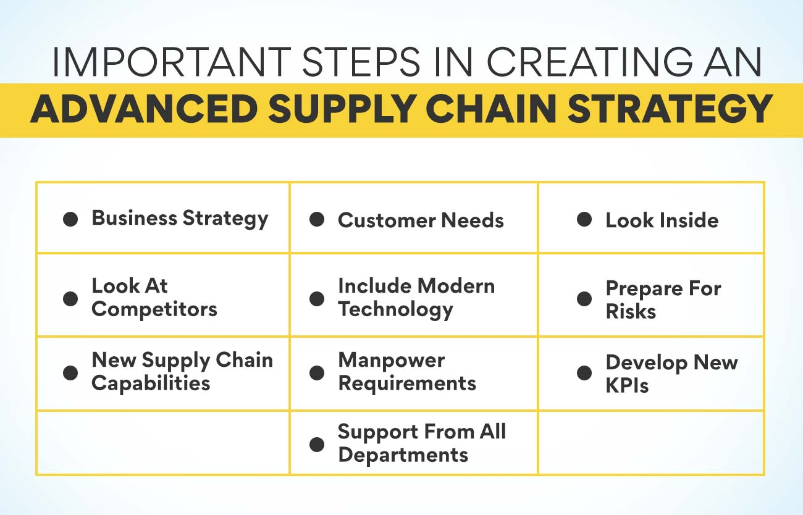
(Wisner, 2021)

5. Application of Strategic Approaches to Supply Chain and Operations Management
Companies select different strategic approaches to control their chain of supply and operations. Here's a critical review of some common strategic approaches:
1. Lean Management: The principle that is mainly run together with lean management is removing waste, if any, and appraising processes to achieve greater efficiency and eventually reduce costs (Wang et al., 2023). Although lean principles are commonly adopted in different sectors, they run into cultural resistance, lack of workforce engagement, and difficulty maintaining improvements, making them less effective. Organizations must, without respite, dedicate themselves to lean principles, incorporate workforce training, and tailor methodologies to fit their distinct business environment to enjoy maximum benefits from lean management.
2. Agile Manufacturing: Through Agile manufacturing, flexibility, responsiveness, and client orientation are encouraged to adjust the production process at the early stage when the requirements of the market change. However, agility practices are not very comfortable with stable environments as they are specifically made to exploit the situations or problems of the upcoming future rather than for the situations of the present time. Therefore, such implementation in organizations may require a significant overhaul of the system, investments in the technology, and dismantling of the hierarchical structures. Companies should encourage innovativeness among employees, set up cross-functional teams, and effectively utilize technology-driven capabilities to push agile manufacturing successfully.
3. Just-in-Time (JIT) Inventory Management: JIT inventory control aims to suppress the inventory holding costs and elevate responsiveness by adjusting the sales forecasts in advance using customers' demand information (Markham, 2020). Although JIT principles can cause cost savings and efficiency, they also face risks, e.g., supply disruptions, zero stock countering, and buffer inventory, to adsorb demand variability. Organizations need to observe the suppliers' risks, routing systems, and demand forecasting and develop options for risk management simultaneously to sustain the benefits of the Just in Time (JIT) inventory system.
4. Total Quality Management (TQM): TQM stresses the importance of lean manufacturing, client feedback, and employee input, upon which strategic decisions are made. Even though TQM principles proved themselves to be quite well applicable to quality upgrading and organizational performance, their every successful implementation requires total view, top-management commitment, and internal alignment with the strategic objectives. Organizations should stand for a culture of quality, and the top brass should ensure that they invest in the training and development of their employees. Also, a feedback mechanism must sustain the TQM initiatives longer.
5. Supply Chain Integration: Supply chain integration includes receiving aligned procedures, objectives, and systems all over the supply chain to ensure communication, visibility, and collaboration (Tiwari, 2021). Integration of supply chains can bring about efficiencies, cost reductions, and better customer service. On the other hand, the bearers of this concept can have obstacles such as data silos, resistance to change, and the complexity of multi-tiered partnerships. Organizations must invest in systems that can interact, create partnerships that start with mutual trust, and use collaborative approaches to realize the advantages of supply chain integration.
To summarize, implementing different ways to supply chain and operations management results from various aspects such as organizational culture, leadership role, technological ability, and becoming more in harmony with strategic goals. Organizations need to appraise the critical elements of the differing approaches, such as their goodwill and the associated challenges, since their choice essentially decides the effectiveness of each approach to performance management and, consequently, the ultimate competitive advantage in the modern business space.

6. Performance Measurement within Supply Chain and Operations Management
Performance measurements in supply chain and operations management are a huge issue since they allow us to explore the efficiency, effectiveness, and general operations of these critical areas in the company. Here's an assessment of its relevance:
Performance Monitoring: Performance measurement enables organizations to track the critical indices and KPIs that aid in monitoring supply chain and operation parameters like the current inventory levels, production efficiency, timely delivery, and consumer satisfaction (Senol et al., 2021). Gathering consistent data along the way, organizations can follow the trend and detect differences and the spots for improvements, which could lead to developing policies that will keep the people at the top of the competition.
Decision Making: Statistical data obtained from operations help make tactical and strategic decisions towards supply chain management. Organizations can discover the jams, wastes, and lightning to the path of prosperity by comprehending the performance metrics; the latter is the light to guide resource allocation, process improvement initiatives, and strategic investments. This makes you realize that decisions align with organizational purpose and plans; thus, it is critical for better operations and competitiveness.
Continuous Improvement: Performance metering is of particular significance since it contributes to developing the permanent enhancement initiative of production and supply chain management. Organizations can create the basis of their performance benchmarks and targets, and as a result, they will set clear objectives for improvement in progress and measure the status in time. It encourages a spirit of relentless improvement, encompassing a culture where team members play their part by identifying, prioritizing, and executing initiatives that result in lower costs, higher efficiencies, and greater satisfaction of the customers. Performance evaluation, therefore, acts as feedback that helps the organization to change with learning, innovations, and the environment, thus making sure that it remains competitive in the long run.
Accountability and Transparency: Performance measurement is one of the means that owner supply chain and operations managers rely on to maintain professional accountability and transparency through providing data on output performance outcomes and resultant measures. The articulation of performance expectations and metrics helps organizations measure the performance individually, in terms of teams and departments, holding individuals, teams, and departments accountable for their contributions to the overall organizational performance. It, therefore, sparks an individual feeling of belongingness, accountability, and eagerness to meet objectives that help achieve targets, unification, and cooperation.

7. Financial, Non-Financial, Single and MultifactorMultifactor Performance Measures
When assessing the performance measures practical for a firm such as Intel, various metrics are required; among them are financial and non-financial metrics, sometimes with single or multifactor measures. Here's an assessment of different performance measures:
Financial Performance Measures: Financial performance indicators are paramount to assessing an organization, such as Intel's financial performance, gauging profitability, and examining its economic health. These tools help determine how well resources are used, whether investments are reasonable, and whether the methods of financial management are appropriate. For instance, Intel can analyze gross margin, operating income, and return on assets to better track its financial performance and profitability.
Non-Financial Performance Measures: Non-financial measures, like customer satisfaction, product quality, employee commitment, and supply chain effectiveness, are aspects of non-financial performance that are as important to companies like Intel as quantitative measures. These indicators measure how well your culture is being executed, which is an essential reflection of internal processes, customer relationships, and the organization's overall capabilities. As such, Intel watches over key operational indicators, including product defect rates, timely deliveries, and employee turnovers, to measure its operational excellence and customer-centricity.
Single-Factor Performance Measures: Single-factor performance measures refer to only some aspects of performance, not all, such as productivity, efficiency, or quality. As an illustration of this, Intel would likely measure manufacturing cycle time, production yield, and defect rate as three key indicators to determine whether manufacturing operations were adequately carried out. These plans, though participative, provide a strategic plan to identify the weaknesses or strengths of the organization.
Multifactor Performance Measures: Multifactor performance measures incorporate a blend of factors to help provide a more complex angle into performance. As an illustration, Intel may apply a balanced scorecard model that covers the financial area, customer perspective, internal process, and growing and learning aspects while assessing performance. By analyzing performance and considering several factors, multi-criteria measures help an organization achieve its goals, measure progress exhaustively, and make integrated decisions within the entire organization.

Eight key performance indicators at the highest operations and the supply chain management level at Intel.
Choosing and using KPIs suitably is critical for Intel's supply chain and operations management. Here's an evaluation of this process
Strategic AassessmentFollowing the establishment of strategic objectives and priorities, KPIs to be used in supply chain and operations management in Intel fit well in a similar situation. A case in point would be the achievement of sales excellence, for which some KPIs such as order shipping time, product quality, and customer sense of urgency may be emphasized to keep up with the strategic objective.
Relevance and Specificity: The metrics app and KPIs need to be appropriate, precise, and practical for a user to get first-hand knowledge of the performance (Marella, 2023). Intel should use KPIs that highlight the key factors that result in its efficient production, timely shipments, good performances of the suppliers, and effective distributions. Intensifying attention to performance details can help isolate the areas that need upgrades and deal with them accordingly, thereby advancing performance.
Measurability and Data Availability: KPIs must be equivalent to such stats and also use trusted data sources that are set to prove validity and accuracy (Blaettler, 2021). Intel should develop firmly built data gathering systems and KPI monitoring platforms using built-in measurement features to collect and sustain the precise and consistent tracking of KPIs over time. One thing that sought to do this may be deploying analytics of high-level, real-time tools for monitoring and utilizing performance data management software.
Benchmarking and Comparison: The company performs an audit to identify where it stands compared to its rivalry in the market, the most appropriate approach, and internal goals to target outstanding performances (Lan et al., 2020). Intel can reach new heights of success using external benchmarks and historical data. This way, the company can get an idea of its relative performance, areas of strength and weakness, and can even draw up strategies to boost competitiveness.
Continuous Improvement and Adaptation: Furthermore, the choice and implementation of KPIs shall be dynamic and cycled, turning Intel flexible to impacted conditions such as market instability, oscillating customer inclination, and technological innovations. Intel has to set proper KPIs based on feedback, performance trends, and strategic aims over time. They must be tweaked regularly to position them among the lead supply chain organizations.
Key performance indicators are critical to evaluating supply chain and operation effectiveness in Intel, as they could identify performance improvement areas, contribute to the implementation of the strategy, and sustain company competitiveness in the semiconductor market. Through the establishment of KPIs congruent with strategic objectives, the importance of using only relevant and specific data, the success of using reliable data sources, comparison to benchmarks, and building up an environment providing opportunities for continuous improvement, Intel will be able to optimize its supply chain and operations and keep the achievements sustainable and growing.

9. Intra- and Inter-Organizational Benchmarking

Intra-organizational Benchmarking
Performance Comparison and Disparity Identification: From inside Intel, the performance dimensions of the divisions, departments, or facilities are compared. Identifying these disparities and differences in performance and the processes that led to these distinctions is a critical part of this process. Another example is when a specific Intel manufacturing unit may produce superior products compared to other units. Experts can investigate the operations of such a single unit and deploy its successful processes in different production sites.
Standardization and Optimization: The company aims to remove duplication and set standardized processes (Gudelj et al., 2021). This helps streamline the organization and introduces a standardized level of quality. Thus, the operational costs become less, and the resources are harnessed in the proper utilization manner.
Continuous Improvement Culture: Benchmarking existing processes inside Intel promotes a never-ending improvement culture. Repeated evaluation of the metrics (KPIs), making the best use of the optimization opportunities, setting up the targets, and tracking down the progress over the prescribed period are exclusively pivotal parts of the process. This lets us keep Intel up-to-date and respond quickly to all changing market needs.

Inter-organizational Benchmarking
Industry Best Practices and Trends: On the other side, Intel examines its performance in benchmark metrics and practices against other companies in the semiconductor community. Assessing an industry's best practices and innovation trends furnishes Intel with an opportunity to learn what tactics the pack leaders use to improve their supply chain and operations management performance. At the same time, this gives Intel an edge and helps it remain at the forefront of the UMLP industry.
Competitive Analysis and Positioning: Intel can analyze these things by externally monitoring competitors' performance. By identifying weaker spots of Intel, it will be possible to devise strategies to balance the odds and turn them in favor of Intel. Furthermore, recognizing its competitors allows Intel to measure how well the products are utilized and how distinct they are from the competitors, thus enabling it to be a market leader known for its operational excellence and reliability.
Supplier Performance Evaluation: Inter-organizational benchmarking contributes to Intel's responsibility to create a consistent standard for its suppliers and strategic partners (Wagner et al., 2024). Intel can pinpoint the most efficient suppliers by evaluating the supplier performance metrics and cultivating these existing relationships into high-value ones. Resolving performance issues with behindhand suppliers will make the system reliable and assure efficiency for the whole supply chain.
In summary, intrinsic and inter-organizational benchmarking are essential tools to track Intel's finest practices in processes, continue with improvements, assess competitiveness, and stay ahead of the market. Although benchmarking provides low-hanging fruit solutions as the first step, Intel can fully embrace the insights from such exercises to enhance overall operational efficiency and effectiveness and solidify its position in the semiconductor leader industry.

References
Blaettler, L., 2021. Identifying essential data to evaluate and monitor energy performance (Doctoral dissertation, North-West University (South Africa)).
Carvalho, A.M., Sampaio, P., Rebentisch, E., Carvalho, J.Á. and Saraiva, P., 2021. The influence of operational excellence on the culture and agility of organizations: evidence from industry. International Journal of Quality & Reliability Management, 38(7), pp.1520-1549.
Gautam, P., Khanna, A. and Jaggi, C.K., 2021. An integrated green supply chain model with product recovery management towards a cleaner system. Journal of Cleaner Production, 320, p.128850.
Gudelj, M., Delic, M., Kuzmanovic, B., Tesic, Z. and Tasic, N., 2021. Business process management model as an approach to process orientation. International Journal of Simulation Modelling, 20(2), pp.255-266.
Ivanov, D., Tsipoulanidis, A. and Schönberger, J., 2021. Global supply chain and operations management. Cham: Springer International Publishing.
Jafari, H., Ghaderi, H., Malik, M. and Bernardes, E., 2023. The effects of supply chain flexibility on customer responsiveness: the moderating role of innovation orientation. Production Planning & Control, 34(16), pp.1543-1561
Kure, H.I., Islam, S. and Mouratidis, H., 2022. An integrated cyber security risk management framework and risk prediction for critical infrastructure protection. Neural Computing and Applications, 34(18), pp.15241-15271.
Lan, N.T.N., Yen, L.L., Ha, N.T.T., Van, P.T.N. and Huy, D.T.N., 2020. ENHANCING ROLES OF MANAGEMENT ACCOUNTING AND ISSUES OF APPLYING IFRS FOR SUSTAINABLE BUSINESS GROWTH: A CASE STUDY. Journal of Security & Sustainability Issues, 10(2).
Le, T.T., Vo, X.V. and Venkatesh, V.G., 2022. Role of green innovation and supply chain management in driving sustainable corporate performance. Journal of Cleaner Production, 374, p.133875.
Marella, G., 2023. Digitalization of quality key performance indicators (Doctoral dissertation, Technische Hochschule Ingolstadt).
Markham, R.R.C., 2020. Reducing inventory through supply chain coordination and improved lead times (Doctoral dissertation, Massachusetts Institute of Technology).
Palange, A. and Dhatrak, P., 2021. Lean manufacturing is a vital tool for enhancing productivity. Materials Today: Proceedings, 46, pp.729-736
Pasi, B.N., Mahajan, S.K. and Rane, S.B., 2020. Smart supply chain management: a perspective of industry 4.0. Supply Chain Management, 29(5), pp.3016-3030
Senol, A., Bakhsh, A.A. and Elshennawy, A.K., 2021. Review of Supply Chain Metrics to Support Performance Excellence. Journal of Management & Engineering Integration, 14(1).
Tiwari, S., 2021. Supply chain integration and Industry 4.0: a systematic literature review. Benchmarking: An International Journal, 28(3), pp.990-1030.
Varl, M., Duhovnik, J. and Tavčar, J., 2020. Agile product development process transformation to support advanced one-of-a-kind manufacturing. International Journal of Computer Integrated Manufacturing, 33(6), pp.590-608.
Wagner, H.T., Beimborn, D. and Moos, B., 2024. What Makes A Firm Innovative? An Inter-Organisational Social Capital Perspective On External Partners' Influence On A Firm's Intellectual Capital. International Journal of Innovation Management, p.2350037.
Wang, C.N., Vo, T.T.B.C., Chung, Y.C., Amer, Y. and Truc Doan, L.T., 2023. Improvement of Manufacturing Process Based on Value Stream Mapping: A Case Study. Engineering Management Journal, pp.1-19.
Wisner, J.D., Tan, K.C. and Leong, K., 2021. Principles of supply chain management: A balanced approach. South-Western, Cengage Learning.

